DEVON & CORNWALL RECORD SOCIETY
registered charity no. 1011931

James Davidson’s East Devon Church Notes
Edited by Jill Cobley

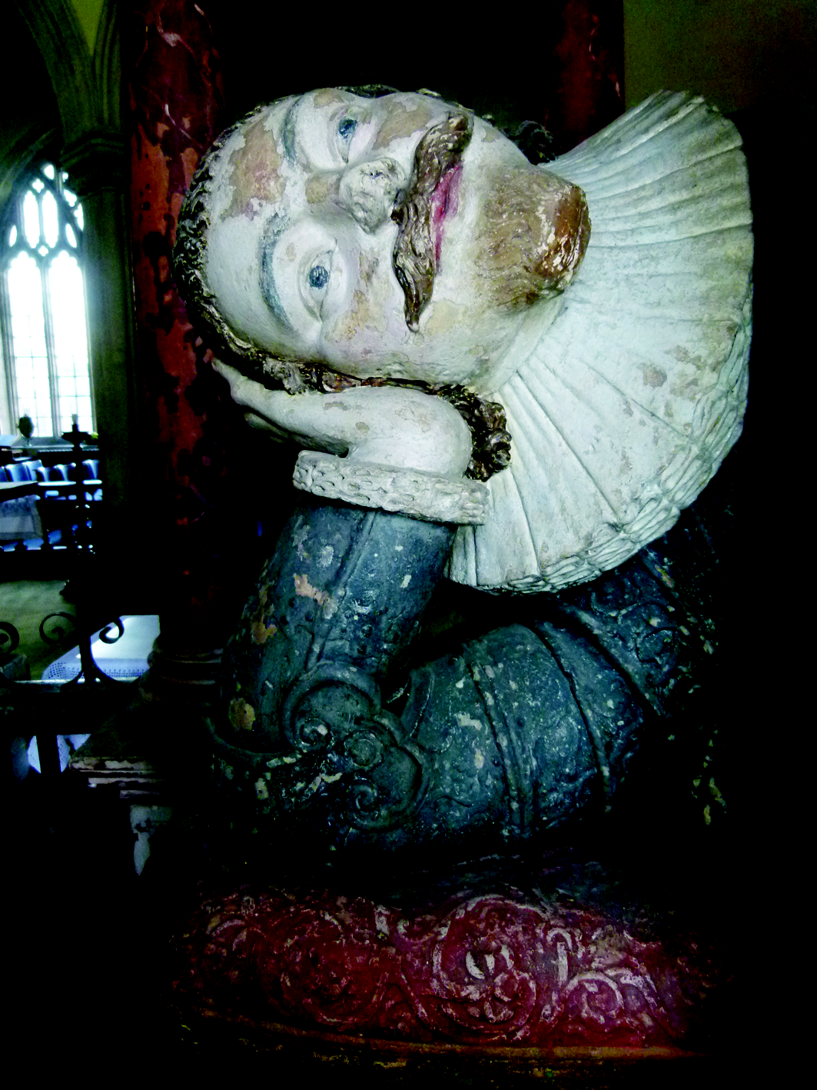

This volume contains the unpublished Church Notes for East Devon recorded by James Davidson (1793-1864). These notes are an eyewitness record of the fabric and fittings of East Devon’s churches in the mid-nineteenth century, before Victorianisation brought about irreplaceable change in almost every parish church. Davidson’s descriptions highlight what has been lost from the archaeological record, and allow us to make comparisons with the churches today. In this way they shed light on these buildings’ history from the Middle Ages onwards, and illustrate the ways in which changes in liturgy and fashion during the late nineteenth century transformed parish churches. Davidson’s records of memorials and inscriptions in the churches also provide material for research into family history from the fifteenth to the nineteenth centuries, as well as into changing attitudes to death and commemoration.

The volume is included in membership of the Society for 2021. It will be published in the autumn and available with membership at £25 or after publication at £30. To join and receive this volume on publication, please complete below and send with a cheque made payable for £25 to the Devon &
Cornwall Record Society by 31 December 2021 to DCRS, Devon Heritage Centre, Great Moor House, Bittern Rd, Sowton, Exeter EX2 7NL

Name:

Delivery address:

Email address (for confirmation of order and despatch):

Please tick next to the statements that apply:
☐ I consent to the DCRS passing my postal address to its publishers for delivery purposes
☐ I am happy for official communications from the DCRS by email
AND/OR
☐ I am happy for official communications from the DCRS by post

Our privacy statement: www.devonandcornwallrecordsociety.co.uk

